Note: All items present in Kryptos
Recipe:
Take a PALIMPSEST
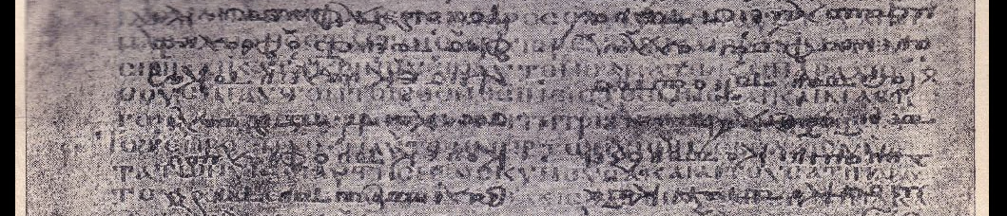
Plot an ABSCISSA:
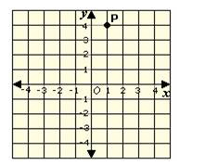
Plot Cartesian coordinates from 0 3,6 2,5 1,4 This gives you a diagonal line, intersecting with the above.
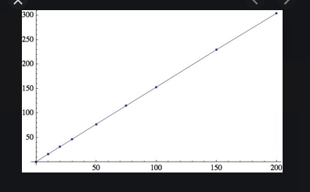

Resulting in… EAST, NORTH-EAST?:

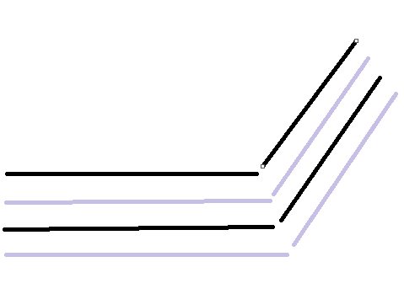

Alternative versions:
Angles - 135 Degrees and 45 Degrees
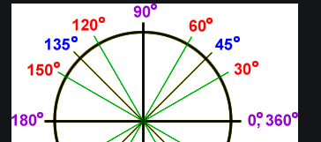

Tut’s Mask
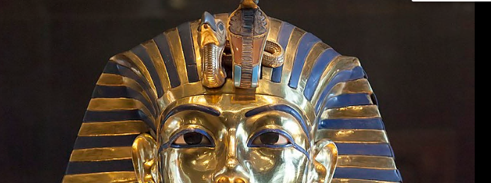

The Parting of Hero and Leander, JMW Turner
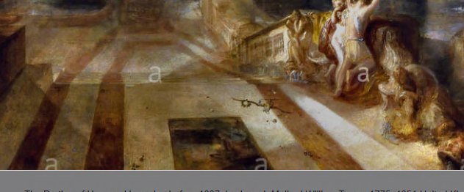

Kryptos, in REFLECTED position.
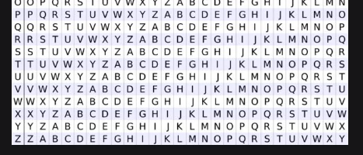

American Stars and Stripes:
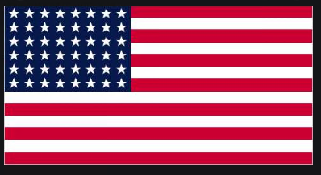

Turkish “Kaik” or Caique, solution by Leander, Gaine’s Cryptanalysis

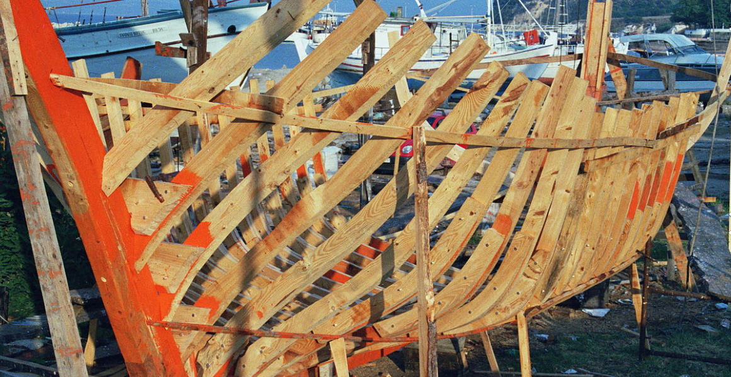

You could say it’s also a horizon meeting the base of a pyramid or pyramidal hourglass bottom.

Conclusion: The Diagonal-Ascissa represents one of the HYDRA Arrays?

